**A dynamically adaptable tough hydrogel with thermo-responsive adhesiveness for the sealing and treatment of gastric perforation**

*Jing Chen,* *Julia S. Caserto, James Webb, Kaavian Shariati, Qingsheng Liu, Bo Wang, Xi Wang and Minglin Ma\**

Dr. J. Chen, J. Caserto, J. Webb, K. Shariati, Dr. Q. Liu, Dr. B. Wang, X. Wang and Prof. M. Ma

Department of Biological and Environmental Engineering, Cornell University, Ithaca, NY 14853, USA.

*Corresponding authors. E-mail: mm826@cornell.edu (M. Ma).

Keywords: *thermo-responsive, adhesive hydrogel plug, gastric perforation*

**Abstract**

A gastric perforation (GP) is a hole in the gastrointestinal tract wall that causes high mortality despite advancements in surgical treatments. Accordingly, there is an unmet need for adhesive biomaterials that have high mechanical, regenerative, and cohesive properties. Herein, we engineer a highly biocompatible, tough, thermo-responsive adhesive hydrogel plug for GP treatment using a double interpenetrated hydrogel network. The physical properties of the hydrogel plug could be finely tuned by changing gelatin, Transglutaminase (TG), and Poly-N-[Tris(hydroxymethyl)methyl]acrylamide (PTH) concentrations. Interestingly, the adhesive hydrogel plug has repeatable and adjustable adhesive properties that are inducible through a temperature change from 37°C to 25°C. Furthermore, in situ crosslinking of the hydrogel plug facilitated easy delivery to the GP, allowing for precise adhesive hydrogel curing according to the required geometry of the defect. In vivo experiments, using a defected mice stomach model, showed that the adhesive hydrogel plug could effectively seal GP defects and encourage gastric mucosa regeneration. Overall, this adhesive hydrogel plug has many advantages, including low cost and ease of production and use. These advantages make the plug a promising biomaterial for GP treatment.

**Main Text**

Peptic ulcer disease (PUD) affects 4 million people worldwide annually1, and the incidence of PUD has been estimated at around 1.5% to 3%. Gastric perforation (GP) is a serious complication of PUD2, 3. Once perforation occurs in the stomach, it can lead to severe peritonitis after bacteria, stomach acid, and partially digested food enters the abdominal cavity. Meanwhile, several complications are often associated with GP including bleeding, sepsis, multi-organ failure, bowel infarction, and wound infection4, which can exacerbate the condition and accounts for more than 70% of deaths associated with PUD5. Surgical intervention in the form of exploratory laparotomy was the initial therapy for GP6-8. Despite improvements in surgical and medical treatments, the mortality rate for GP is 30%, while the mortality rate for cases compounded by diffuse peritonitis is up to 70%9. Furthermore, sutures require delicate control and prolonged time for application, which is problematic in emergency circumstances10. In addition, existing medical glues have significant drawbacks. For example, cyanoacrylate glue exhibits low biocompatibility, difficult handling, and poor integration with stomach tissues11. Fibrin glue/thrombin can stop bleeding, but often suffers from weak adhesion, poor mechanical properties and short degradation time12, 13. To address these problems, new easy-to-apply treatment biomaterials with strong, dynamic adhesion, tough mechanical properties, and tunable biodegradability are highly desirable in clinical settings.

Adhesive hydrogels represent a promising candidate for GP treatment. For example, dry double-sided hydrogel tape was made from a combination of a biopolymer (gelatin or chitosan) and crosslinked poly(acrylic acid) (PAA) grafted with N-hydrosuccinimide ester12, which provides a fluid-tight sealing of a fluid-filled perforated pig stomach by covalent crosslinking with amine groups on the tissue surface. However, more in vivo work needs to be done to further demonstrate its potential for clinical application. Maeng and co-workers reported an epidermal growth factor-containing chitosan hydrogel, for treatment of gastrointestinal ulcers14. The recovery of the ulcers in the gel-treated group was accelerated in comparison to the non-treated group. However, the model was created only with an ulcer that did not completely perforate the gastric wall, which is significantly different from the real GP situation. Furthermore, the hydrogel’s efficacy was limited because it did not adhere to stomach tissue. In order to endow adhesive properties to the hydrogel, poly(N-acryloyl 2-glycine) hydrogels were developed to bond perforated stomach surface via multiple hydrogen bonding interaction15. The rabbits repaired with the hydrogels all survived and showed a good health status after surgery, while a 44.4% mortality rate was observed after treatment with surgical sutures. However, this research was limited due to poor adaptability to stomach tissue and lack of detailed information, such as mucosa regeneration data for GP treatment. Indeed, an ideal biomaterial for GP treatment must satisfy several requirements: (i) strong adhesion to the native stomach and adaptability to dynamic movement (ii) stable mechanical properties with appropriate toughness, (iii) high biocompatibility and tunable biodegradability, matching endogenous tissue regeneration and (iv) ease of application and use in clinical settings.

Here, we have developed a gelatin-based, thermo-responsive**,** adhesive, and tough hydrogel plug for GP treatment. The adhesive plug was made from a double interpenetrated hydrogel network (Figure 1A). The primary network consisted of gelatin crosslinked with transglutaminase (TG), which could serve as a thermo-responsive and adhesive unit. The secondary network was made of a triple hydrogen bonding cluster polymer (PTH) that was crosslinked with borate. PTH was polymerized from N-[Tris(hydroxymethyl)methyl]acrylamide (Figure S1 and S2). This network was dynamically crosslinked, which favors dissipation of energy, and large improvements in not only the mechanical properties, but also the adhesive strength of the whole system.

To make the adhesive plug dynamically adaptable and deformable to stomach tissue, we first screened the optimal ratio of gelatin and TG to make a tough and adhesive hydrogel primary network with relatively short and operable gelation time. When the TG concentration was fixed to 30 U/mL, the maximum elastic modulus (G’), measured using a rheology test, increased with increasing solid gelatin content from 5% to 10% solid content while decreased when reached to 20% (Figure 1B). A maximum G’ of 1112 Pa was achieved for the hydrogel with 10% gelatin (Figure 1C), which was greater than that of 20% and 5% gelatin (927.7 and 426.3 Pa, respectively). However, the gelation time was largely reduced with increased gelatin solid content, achieving the shortest time of 73s with 20% gelatin content (Figure 1D). Enzymatic degradation of the 10% and 20% gelatin hydrogels crosslinked with 30 U/mL of TG was also characterized (Figure 1E). The enzymatic degradation of gelatin hydrogels was measured by incubation in different concentrations (2.5 and 5 µg/mL) of a collagenase type II solution in PBS for up to 15 days. Results showed that the collagenase concentration could directly affect in vitro degradation rate of the gelatin hydrogels. For 20% gelatin groups, 5 µg/mL collagenase showed 94.9% degradation after 13 days of incubation. However, 83.3% degradations were obtained after 13 days for 2.5 µg/mL collagenase. The degradation rate could be further accelerated by reducing the gelatin content. For 10% gelatin groups, it showed 98.8% degradation after 9 days of incubation. Considering that the high gelatin content would favor more retention time *in vivo,* we chose 20% gelatin content and varied the TG concentration for further experimentation. Even though higher TG concentrations (40 U/mL and 60 U/mL) achieved higher G’ of 2511 and 4576 Pa (Figure 1F & 1G) and lower gelation times of 58 and 22 s (Figure 1H), both adhesive strengths of the higher TG concentrations were much lower than the 20 U/mL group (Figure 1I). Therefore, 20% gelatin solid content with 20 U/mL of TG was chosen for further experiments.

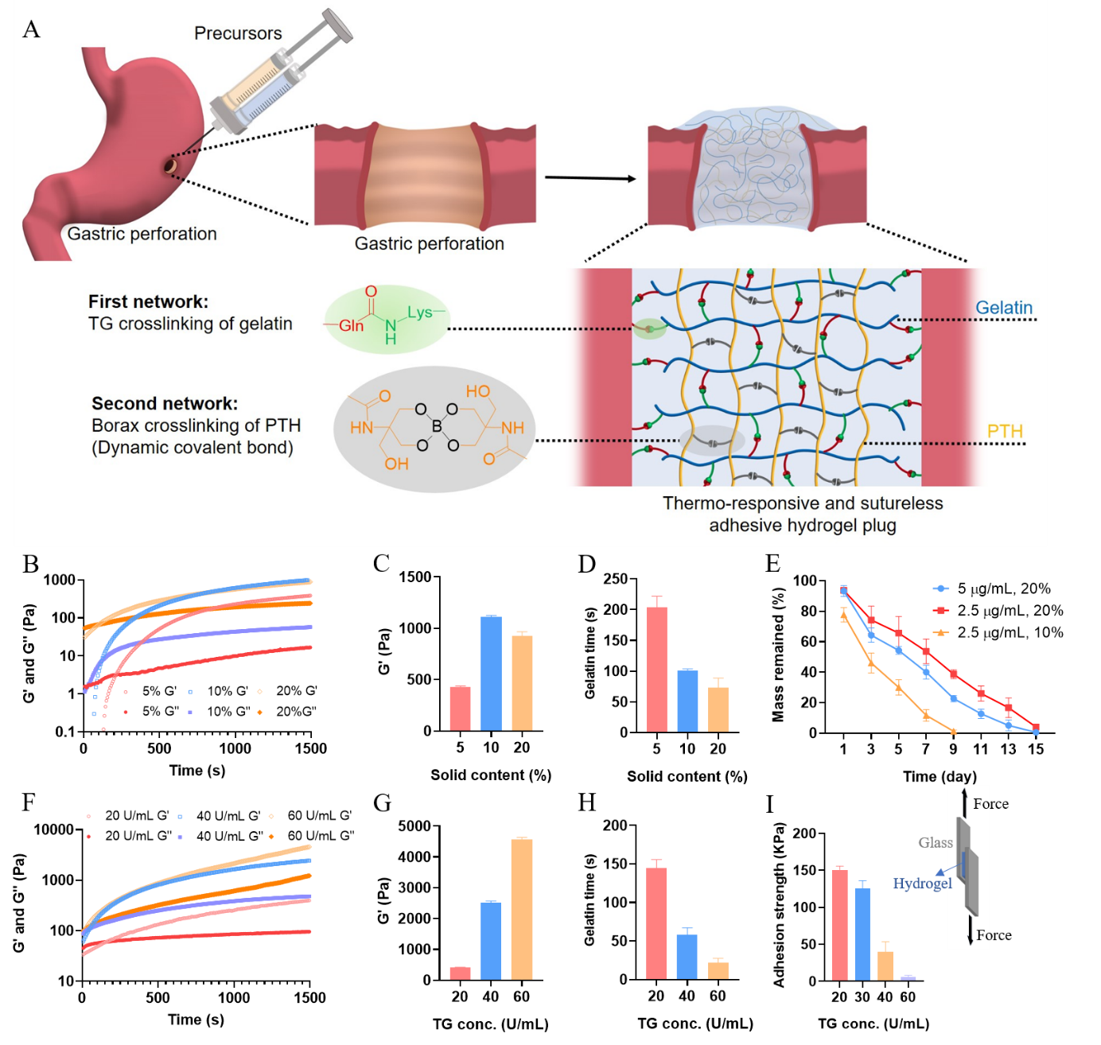

**Figure 1.** A) Scheme of a thermo-responsive and sutureless adhesive hydrogel plug for the treatment of gastric perforation. B) Hydrogels crosslinked by 30 U/mL TG with different solid content of gelatin were examined by a time sweep. Corresponding statistics C) loss modulus (G’) and D) gelation time of hydrogels. E) *In vitro* degradation of 10% and 20% (w/v) gelatin hydrogels crosslinked by 30 U/mL TG, in different concentrations of collagenase type II (Col II) solution in PBS and 37°C over time. F) 20% (w/v) gelatin hydrogels crosslinked by different concentration of TG were examined by a time sweep. Corresponding statistics G) loss modulus (G’) and H) gelation time of hydrogels. I) Adhesion strength of 20% (w/v) gelatin hydrogels crosslinked by different concentration of TG.

An optimal gastrointestinal sealant biomaterial should be elastic enough to allow for peristaltic movements16, 17. In order to further enhance its mechanical properties as well as adhesive strength, PTH dynamically crosslinked by 0.4 mM of borax was chosen as a secondary network. Figure 2A shows the typical tensile stress-strain curves of the hydrogels under tensile tests. The maximum tensile strain under 37°C increased with PTH content and reached a maximum value of 1323% at 10 % (w/v), much higher than that of the GT-PTH-20-5 hydrogel (938%), and in sharp contrast to that of the GT-20 and GT-PTH-20-20 hydrogels (419% and 467%), respectively. These results demonstrated that the GT20-PTH10 hydrogel was sufficiently stretchable and tough. As shown in Figure. 2B, the hydrogel was stretched 13 times its initial length (Video V1). The fracture energy showed a similar trend, as demonstrated by the single edge notched tests (Figure 2C). A maximum fracture energy of 1450 Jm-2 was achieved at PTH10. Meanwhile, the compressive modulus of GT20-PTH10 (334 KPa) hydrogel was higher than that of GT20 (311 KPa) without any PTH addition (Figure 2D). It also withstood a high compression to complete deformation without breaking. After the compressive load was removed, the GT20-PTH10 hydrogel recovered automatically and rapidly to its initial shape (Figure 2E and Video V2). However, the maximum tensile strain under 25°C reduced to 469%, in contrast to that of GT-20 (221%) (Figure 2F). This highlights the wide range of controllable mechanical properties, which can be obtained just by changing temperature. When the temperature was increased to 37°C, the hydrogen bonds between gelatin polymer chains were broken, but these bonds could be reversibly reformed when the temperature was reduced to 25°C (Figure 2G).

The adhesive strength under 37°C, evaluated by a lap-shear test, increased with the ratio of PTH from 0 to 10% (Figure 3A), with the maximum reaching 251 KPa at PTH10 (Figure 3B). However, the adhesive strength reduced to 163 KPa when PTH further increased to 20%. The GT20-PTH10 hydrogel strongly adhered to a rubber glove and plastic cell culture lid with a clear adhesion interface after lifting the hydrogel (Figure 3C). However, nothing remained at the surface of the plastic lid, indicating its high adhesive and mechanical strength (Video V3). Meanwhile, adhesion could be adjusted according to temperature. When the temperature was reduced from 37°C to 25°C, the adhesive strength reduced to almost zero (Figure 3D). If we repeated the cycle, the adhesive strength could be maintained for almost 60 cycles with only slight reduction. Lastly, we confirmed the GT20-PTH10 hydrogel was highly adhesive to biological tissues including the stomach, liver, kidney, heart, and spleen (Figure 3E).

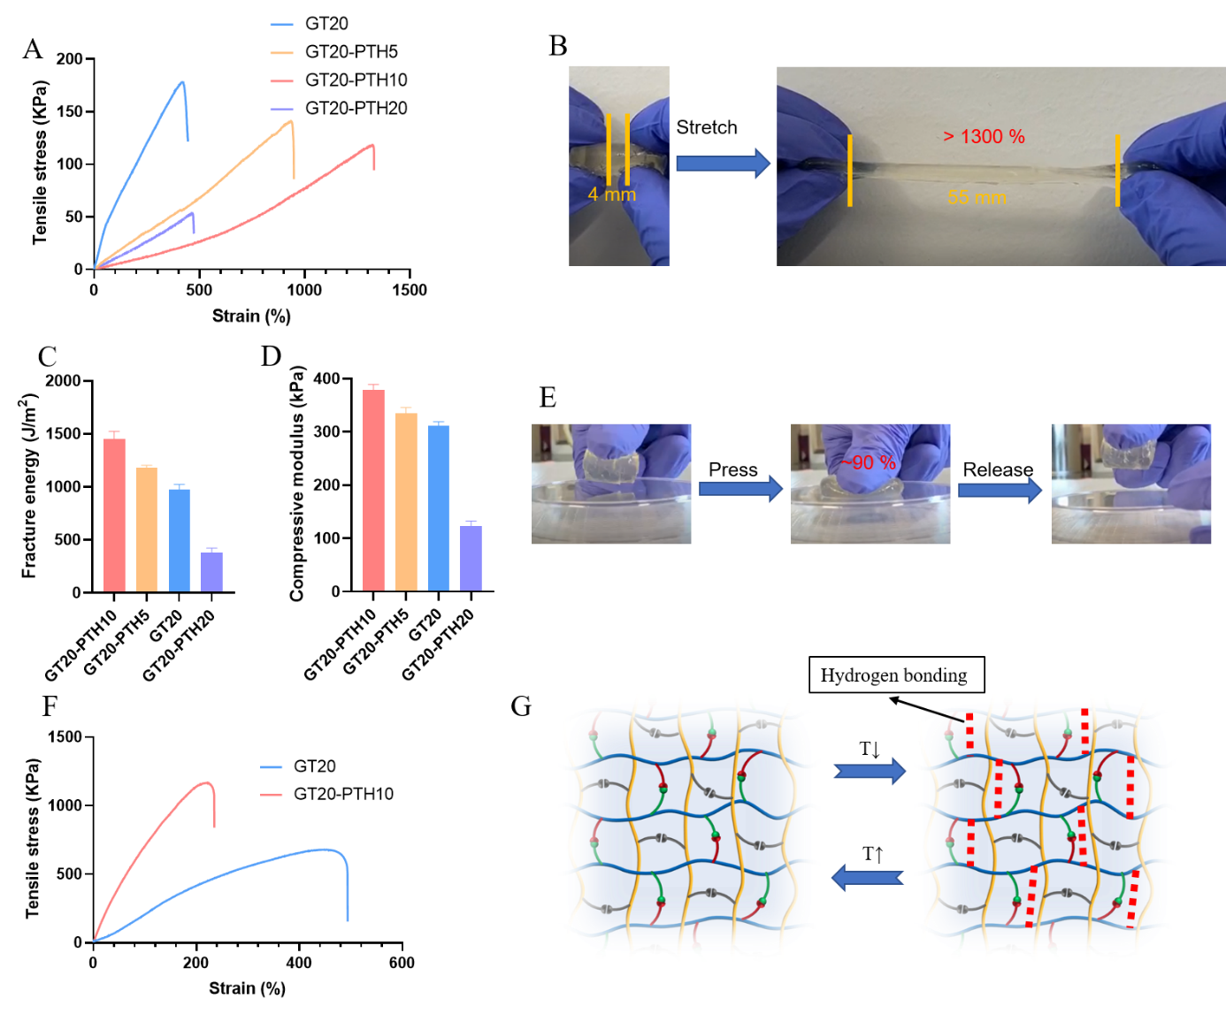

**Figure 2**. A) Typical tensile stress-strain curves of the 20% (w/v) gelatin hydrogel crosslinked by 20 U/mL TG as a first network and different content of PTH crosslinked by 0.4 mM of borax as a secondary network under 37°C. B) The GT20-PTH10 hydrogel was elongated to 13 times its initial length under 37°C. C) Fracture energy of GT20-PTHx, x varied from 0 to 20 and D) corresponding compressive modulus of different hydrogels. E) The GT20-PTH10 hydrogel was compressed to 90% and recovered immediately. F) Tensile stress-strain curves of the GT20-PTH10 and GT20 hydrogels under 25°C. G) Scheme of inter-network of GT20-PTHx hydrogels undergoing reverse temperature change.

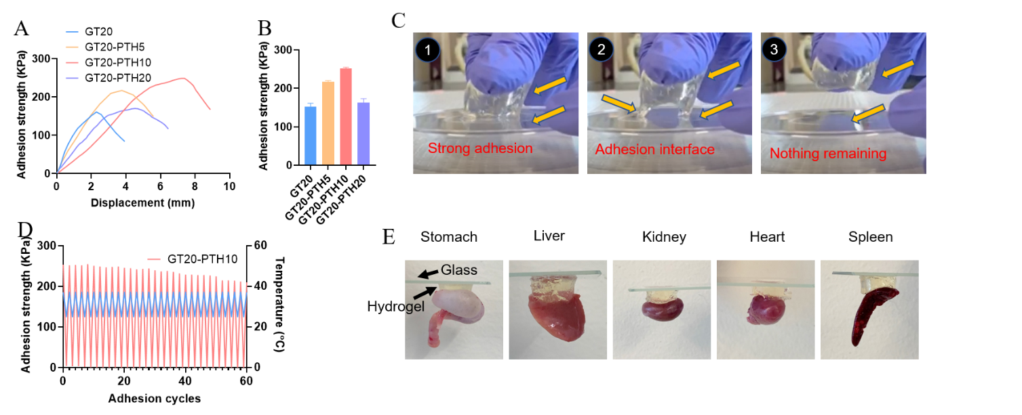

**Figure 3.** A) Adhesion strength curve of different hydrogels to a glass slice under 37°C and B) corresponding statistic of adhesive strength (n=3). C) Optical images of the GT20-PTH10 hydrogels sticking to the lid of cell culture dish and the adhesion interface when lifted under 37°C. D) Inverse adhesion property of GT20-PTH10 hydrogel under 37°C and 25°C. E) The GT20-PTH10 hydrogel adhered to various tissue surfaces including the stomach, liver, kidney, heart, and spleen.

Ideally, an adhesive hydrogel for GP treatment should present no cytotoxicity. It should also permit cells of the injured tissue to migrate into the adhesive hydrogel for long-term cell integration and repair18, 19. Therefore, we aimed to evaluate the *in vitro* cyto-compatibility and cell migration potential for the engineered adhesives using 2D cell seeding and scratch tests. To accomplish this, the cyto-compatibility of the engineered adhesive hydrogels was assessed *in vitro*. The viability, adhesion, and proliferation activity of MSC cells seeded on a GT20-PTH10 adhesive hydrogel were evaluated using a commercial kit for LIVE/DEAD assays and MTT tests. The results were compared to the viability of cells seeded on tissue well culture plates, which served as the control. The results showed that the cells seeded on tissue well culture plates and GT20-PTH10 adhesive hydrogels both exhibited high viability (>100%) 2 and 3 days after seeding (Figure 3A). The MTT quantification of cell viability also confirmed this observation (Figure 3B). The *in vitro* scratch assay revealed that MSC cells seeded on the surface of both well plates and GT20-PTH10 adhesive hydrogels could migrate to the scratched area within 24 hours (Figure 3C). To quantify migration to the wounded area, we compared cell density in the scratched area to the surrounding cell density. The results showed that the relative cell density for the GT20-PTH10 adhesive hydrogel was higher than that of the control (tissue culture plate) 2 and 3 days after creating the scratch (Figure 3D). For example, the relative cell density for GT20-PTH10 adhesive hydrogel was 100 ±5%, which was higher than the control (92 ±3% for well plate) after 3 days. This indicated that GT20-PTH10 adhesive hydrogel could facilitate cell migration and proliferation.

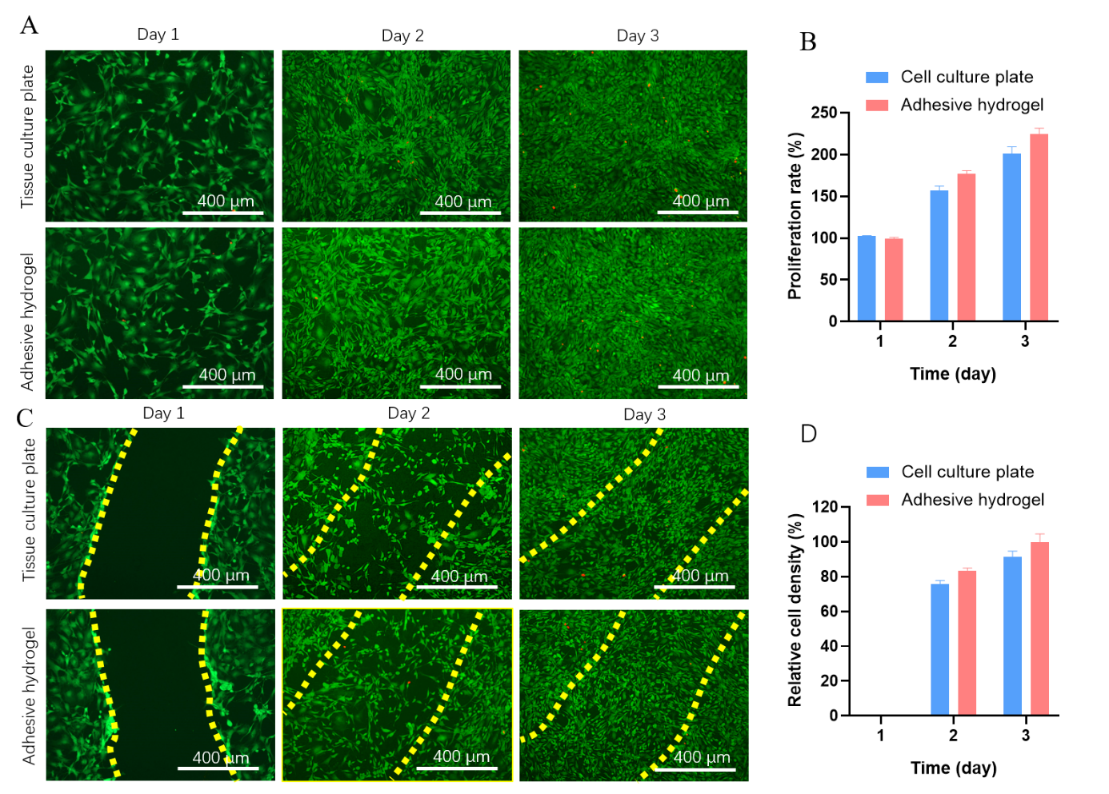

**Figure 4.** A) Representative LIVE/DEAD images from MSC cells seeded on tissue culture well-plate and GT20-PTH10 hydrogel surface. B) Quantification of cell proliferation rate on GT20-PTH10 hydrogel surface compared to tissue culture well plate after 1, 2, and 3 days of culture. C) Representative LIVE/DEAD images of MSC cells grown on tissue culture well plate and GT20-PTH10 hydrogel at 1, 2, and 3 days after scratching. D) Quantification of relative cell densities migrated to the scratched area on GT20-PTH10 hydrogels and control samples, at days 1, 2, and 3.

Following encouraging *in vitro* data, we first assessed the adhesion efficacy of our engineered GT20-PTH10 adhesive hydrogel *ex vivo*. After creating an approximately 5 mm diameter hole, gelatin (mixed with PTH and borax) and TG were separately infused into a dual-syringe and incubated in a 37°C water bath before being injected into the GP and solidifying as a plug to block the hole (Figure 5A). After the GT20-PTH10 adhesive hydrogel plug was applied, we used tweezers to apply pressure to the stomach tissue. Figure 5B and Video V4 show that no gastric content, including acid and food residue, leaked from the stomach, indicating strong adhesion between the stomach and the GT20-PTH10 adhesive hydrogel plug. However, a large amount of gastric content squeezed out from stomachs without any treatment (Video V5). Before the GP treatment test, we first investigated the adhesive properties of the GT20-PTH10 adhesive hydrogel plug *in vivo*. The GT20-PTH10 adhesive hydrogel plug was implanted on the surface of a healthy mouse stomach. The results showed that the hydrogel plug tightly adhered to the stomach surface even with some degradation after 10 days (Figure 5C). Meanwhile, when we applied the hydrogel plug to the GP site, bleeding was stopped immediately (Figure 5D and Video V6), suggesting high adhesion of the hydrogel *in vivo*. Interestingly, no adhesion between other heathy organs and the stomach could be found after hydrogel plug treatment after 10 days (Figure 5E), but severe tissues adhesion could be easily observed for suture treatment (Figure 5F). Moreover, Figure 5E also showed that the stomach inner mucosa surface remains smooth and intact after GT20-PTH10 adhesive hydrogel treatment. Gastric mucus is a glycoprotein that serves two purposes: the lubrication of food masses to facilitate movement within the stomach and the formation of a protective layer over the lining epithelium of the stomach cavity. The GP defected areas exposed to corrosive gastric juice may induce a slow-healing of gastric mucosa, which results in patients suffering from this complication20. Therefore, whether or not the mucosa fully regenerates is the health hallmark of stomach after GP treatment21, 22. The thickness of gastric mucosa following GT20-PTH10 adhesive hydrogel plugging is much higher than that of the suture group (Figure. 5G and 5H). The quantification of gastric mucosa thickness also confirmed this observation (Figure. 5I).

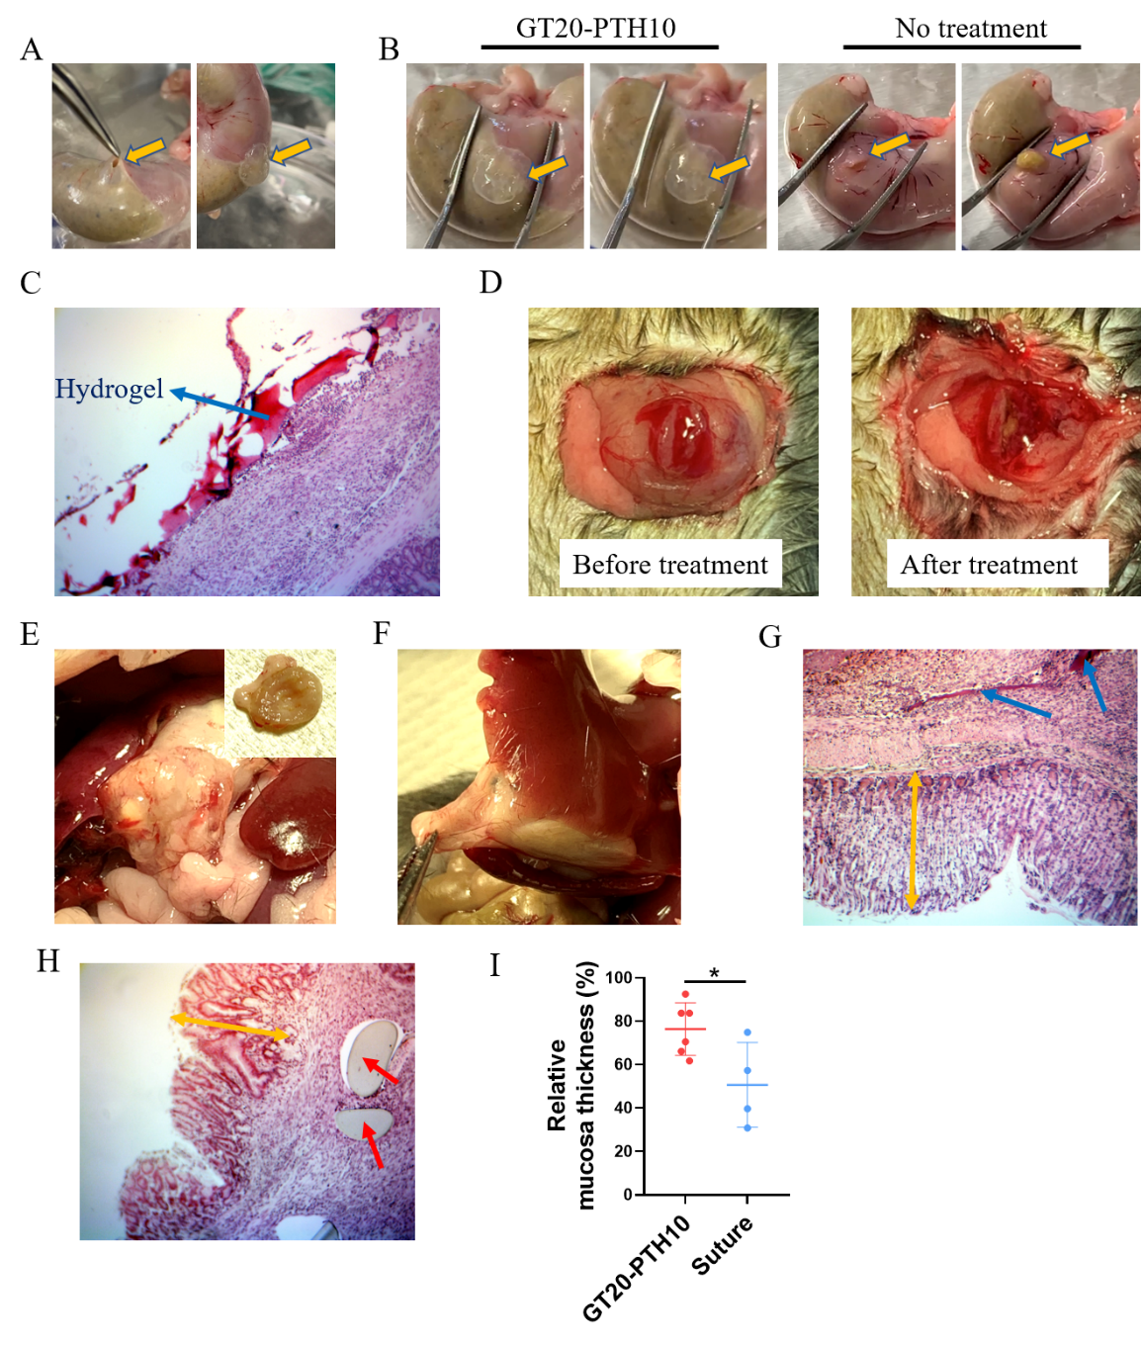

**Figure 5.** A) Representative images for creating a 5mm hole on a rat’s stomach and blocking the hole with a GT20-PTH10 hydrogel plug. Representative images of a stomach B) treated with a GT20-PTH10 hydrogel plug and without any treatment before and after pressing with a tweezer. C) H&E staining of GT20-PTH10 hydrogel plug sticking to a healthy stomach surface after 10 days. D) Representative images of a perforated stomach before and after treatment of GT20-PTH10 hydrogel plug. Representative images of a perforated mouse stomach with treatment of a E) GT20-PTH10 hydrogel plug and F) suture after 10 days. H&E staining of G) GT20-PTH10 hydrogel plug and H) suture group after 10 days. Blue arrows point to the remaining hydrogels and the red ones point to the suture. Yellow arrows represent the mucosa thickness. I) Gastric mucosa thickness of GT20-PTH10 hydrogels and suture treatment groups.

In summary, we report an adhesive hydrogel plug that was applicable for gastric repair in mice. There are a few design principles that are worth reiterating. The adhesion properties can be attributed to the high density of hydrogen bonds and the covalent bonds between the hydrogel and stomach tissues. The adhesive properties can be easily adjusted by adapting the degree of crosslinking using temperature. Due to strong adhesive and mechanical properties of the hydrogels, the plugs could strongly adhere to the GP site and not only protect the surrounding tissue from infection, but also help regenerate the gastric tissue. The hydrogel plugs favored mucosa regeneration relative to the suture group after 10 days in the GP mouse model. This study provides a proof of concept for the potential use of the GP treatment in developing an internal plug for biomedical applications.

**Acknowledgements**

This work was partially supported by the National Institutes of Health (NIH, 1R01DK105967-01A1), the Novo Nordisk Company, the Juvenile Diabetes Research Foundation (JDRF, 2-SRA-2018-472-S-B) and the Hartwell Foundation.

**Materials.**

N-[Tris(hydroxymethyl)methyl]acrylamide (THMA, 93%), collagenase type II and Ammonium persulfate (APS, 98%) were purchased from Sigma-Aldrich, Transglutaminase was purchased from Moo Gloo.

**Methods**

**Synthesis of PTH**

PTH was synthesized by a free radical polymerization method. THMA (910 mg, 5.2 mmol) was dissolved into 6 mL of D.I. water under nitrogen atmosphere. Then APS (23 mg, 0.1 mmol) was added to initiate the polymerization at 60 ℃. After 1h, the temperature was adjusted to 70 ℃ for further 12 h. After the reaction, PTH was obtained by dialysis (Spectra/Pore, molecular weight cut off (MWCO) of 3500) in D.I. water followed by freeze-drying. 1H NMR (400 MHz, D2O, Figure S2, δ): CH and CH2 on polymer chain: 3.82.

**Fabrication of adhesive hydrogels**

A certain amount of gelatin (mixed with PTH) and TG (mixed with 0.4 mM of borax) with 1:1 (v/v) ratio was first separately infused inside a 3 mL dual-syringe (Merlin Packaging Technologies, Inc.) which connected with a micro-mixer and incubated into 37°C water bath, then they could be injected into mold to fabricate the adhesive hydrogels.

***In vitro* enzymatic degradation of the gelatin hydrogels**

The *in vitro* degradation of gelatin hydrogels was examined as described previously23. Disc-shaped gelatin hydrogel samples (d=6 mm; h=3 mm) were formed as previously described. Next, the initial weights of the samples were measured, and the samples were incubated in different concentrations (2.5 and 5 µg/mL) of collagenase type II in PBS for 1, 3, 5, 7, 9, 11, 13 and 15 days. At each time point, the final weights of samples after dried were measured. The degradation percentage of each sample was calculated based on weight loss over time.

**2D cell seeding on adhesive hydrogels**

First, 500 µL of hydrogel was injected into each well. Next, 50 µL of MSC cell solution (2 × 106 cells/mL) were seeded on each sample. After 45-min incubation, 360 µL of cell culture media was added to each sample and maintained at 37°C and 5% CO2 for 7 days. In addition, cells at the same density were also seeded inside 24-well tissue culture plates.

**2D cell scratch test**

The adhesive hydrogel was prepared as previously described. 500 µL of hydrogel was injected into each well. Then MSC cells (2 × 106 cells/ml) were then seeded on the hydrogels and maintained at 37°C and 5% CO2. After 2 days, the cell layer on the surface of the hydrogels was scratched using a 1-ml pipette tips. The cells were stained at day 0, 1, 2 and 3 after creating the scratch. Polystyrene 24-well plates were used as control.

**In Vitro Cytotoxicity Assay**

MSC cells were plated in a 96-well plate (1 × 104 cells/well) in an atmosphere containing 5% CO2 for 24 h at 37 °C. The prescribed amounts of adhesive hydrogels were applied to each well. After 1, 4 and 7 days 3-(4,5-dimethylthiazol-2-yl)-2,5-diphenyl tetrazoliumbromide (MTT) solution in PBS (10 μL, 5 mg/mL) was added. After incubation for 4 h, the supernatant was carefully aspirated, and the MTT-formazan generated by live cells was dissolved in 150 μL of DMSO for 20 min. Absorbance at a wavelength of 490 nm was measured using a microplate reader (Bio-Tek, ELX808IU). Relative cell viability (%) was determined by comparing absorbance at 490 nm with control wells containing only cell culture medium. The experiments were performed in quartets, and data were presented as an average ± SD.

**GP treatment *in vivo***

All animal studies were approved by the Cornell Institutional Animal Care and Use Committee and anesthetized using 3% isoflurane in oxygen and maintained at the same rate throughout the procedure. A ∼5-mm incision was made above the stomach. After creating an approximately 5mm diameter hole, the gelatin (mixed with PTH and borax) and TG were first separately infused inside a dual-syringe and incubated into 37°C water bath before being injected into the hole, subsequently undergoing gelation to form a plug to block the hole. The incision was closed using 5–0 taper polydioxanone (PDS II) absorbable sutures. The mice were euthanized at desired time points post implantation to acquire the stomach tissues. They were then transferred into 4% paraformaldehyde for fixation.

**Histological Analysis**

At the end of the treatment, mice of all groups were euthanized, and the stomachs were excised. Then they were fixed with 4% paraformaldehyde solution and embedded in paraffin. The sliced organ tissues mounted on the glass slides were stained by hematoxylin and eosin (H&E) and observed by digital microscope (Leica Q Win).

**Supplementary Figures**



Figure S1. Synthesis of PTH. Conditions: APS, H2O, 60 ℃, 1 h→70 ℃, 24 h.



Figure S2. 1H-NMR spectrum of THMA and PTH. Vinyl double bond peak (peak a, b and c) of THMA monomer at δ6.33, δ6.20 and δ5.76 disappeared indicated that PTH has been successfully synthesized.

**References**

1. Chung, K. T.; Shelat, V. G., Perforated peptic ulcer-an update. *World J. Gastroenterol.* **2017,** *9* (1), 1.

2. Ramakrishnan, K.; Salinas, R. C., Peptic ulcer disease. *Am. Fam. Physician* **2007,** *76* (7), 1005-1012.

3. Najm, W. I., Peptic ulcer disease. *Prim. Care* **2011,** *38* (3), 383-394.

4. Gossman, W.; Tuma, F.; Kamel, B. G.; Cassaro, S., Gastric Perforation. In *StatPearls [Internet]*, StatPearls Publishing: 2019.

5. Bertleff, M. J.; Lange, J. F., Perforated peptic ulcer disease: a review of history and treatment. *Dig. Surg.* **2010,** *27* (3), 161-169.

6. Byun, J.; Kim, H. Y.; Noh, S. Y.; Kim, S. H.; Jung, S. E.; Lee, S. C.; Park, K. W., Neonatal gastric perforation: a single center experience. *World J. Gastroenterol.* **2014,** *6* (8), 151.

7. Michelet, I.; Agresta, F., Perforated peptic ulcer: laparoscopic approach. *Eur. J. Surg.* **2000,** *166* (5), 405-408.

8. Glüer, S.; Schmidt, A. I.; Jesch, N. K.; Ure, B. M., Laparoscopic repair of neonatal gastric perforation. *Journal of pediatric surgery* **2006,** *41* (1), e57-e58.

9. Shin, R.; Lee, S. M.; Sohn, B.; Lee, D. W.; Song, I.; Chai, Y. J.; Lee, H. W.; Ahn, H. S.; Jung, I. M.; Chung, J. K., Predictors of morbidity and mortality after surgery for intestinal perforation. *Ann. Coloproctol.* **2016,** *32* (6), 221.

10. Svanes, C., Trends in perforated peptic ulcer: incidence, etiology, treatment, and prognosis. *World journal of surgery* **2000,** *24* (3), 277-283.

11. Sani, E. S.; Kheirkhah, A.; Rana, D.; Sun, Z.; Foulsham, W.; Sheikhi, A.; Khademhosseini, A.; Dana, R.; Annabi, N., Sutureless repair of corneal injuries using naturally derived bioadhesive hydrogels. *Sci. Adv.* **2019,** *5* (3), eaav1281.

12. Yuk, H.; Varela, C. E.; Nabzdyk, C. S.; Mao, X.; Padera, R. F.; Roche, E. T.; Zhao, X., Dry double-sided tape for adhesion of wet tissues and devices. *Nature* **2019,** *575* (7781), 169-174.

13. Taboada, G. M.; Yang, K.; Pereira, M. J.; Liu, S. S.; Hu, Y.; Karp, J. M.; Artzi, N.; Lee, Y., Overcoming the translational barriers of tissue adhesives. *Nat. Rev. Mater.* **2020**, 1-20.

14. Maeng, J. H.; Bang, B. W.; Lee, E.; Kim, J.; Kim, H. G.; Lee, D. H.; Yang, S.-G., Endoscopic application of EGF-chitosan hydrogel for precipitated healing of GI peptic ulcers and mucosectomy-induced ulcers. *J. Mater. Sci.: Mater. Med.* **2014,** *25* (2), 573-582.

15. Cui, C.; Wu, T.; Chen, X.; Liu, Y.; Li, Y.; Xu, Z.; Fan, C.; Liu, W., A Janus Hydrogel Wet Adhesive for Internal Tissue Repair and Anti‐Postoperative Adhesion. *Adv. Funct. Mater.* **2020,** *30* (49), 2005689.

16. Bae, K.-B.; Kim, S.-H.; Jung, S.-J.; Hong, K.-H., Cyanoacrylate for colonic anastomosis; is it safe? *Int. J. Colorectal Dis.* **2010,** *25* (5), 601-606.

17. Vuocolo, T.; Haddad, R.; Edwards, G. A.; Lyons, R. E.; Liyou, N. E.; Werkmeister, J. A.; Ramshaw, J. A.; Elvin, C. M., A highly elastic and adhesive gelatin tissue sealant for gastrointestinal surgery and colon anastomosis. *J. Gastrointest. Surg.* **2012,** *16* (4), 744-752.

18. Yang, Y.; Zhang, J.; Liu, Z.; Lin, Q.; Liu, X.; Bao, C.; Wang, Y.; Zhu, L., Tissue‐integratable and biocompatible photogelation by the imine crosslinking reaction. *Adv. Mater.* **2016,** *28* (14), 2724-2730.

19. Liang, S.; Zhang, Y.; Wang, H.; Xu, Z.; Chen, J.; Bao, R.; Tan, B.; Cui, Y.; Fan, G.; Wang, W., Paintable and rapidly bondable conductive hydrogels as therapeutic cardiac patches. *Adv. Mater.* **2018,** *30* (23), 1704235.

20. Wang, M.; Li, Y.-Q.; Cao, J.; Gong, M.; Zhang, Y.; Chen, X.; Tian, M.-X.; Xie, H.-Q., Accelerating effects of genipin-crosslinked small intestinal submucosa for defected gastric mucosa repair. *J. Mater. Chem. B* **2017,** *5* (34), 7059-7071.

21. Atuma, C.; Strugala, V.; Allen, A.; Holm, L., The adherent gastrointestinal mucus gel layer: thickness and physical state in vivo. *Am. J. Physiol. Gastrointest. Liver Physiol.* **2001,** *280* (5), G922-G929.

22. Vasconcelos, P.; Kushima, H.; Andreo, M.; Hiruma-Lima, C. A.; Vilegas, W.; Takahira, R. K.; Pellizzon, C., Studies of gastric mucosa regeneration and safety promoted by Mouriri pusa treatment in acetic acid ulcer model. *J. Ethnopharmacol.* **2008,** *115* (2), 293-301.

23. Shirzaei Sani, E.; Portillo-Lara, R.; Spencer, A.; Yu, W.; Geilich, B. M.; Noshadi, I.; Webster, T. J.; Annabi, N., Engineering adhesive and antimicrobial hyaluronic acid/elastin-like polypeptide hybrid hydrogels for tissue engineering applications. *ACS Biomater. Sci. Eng.* **2018,** *4* (7), 2528-2540.